REPORT OF UNDP CAR FOR THE IMPLEMENTATION OF THE FUNDING WINDOWS PROJECT
Quantitative Report
Relevant SP output  Output 5.5. Policy frameworks and institutional mechanisms enabled at the national and sub-national levels for the peaceful management of emerging and recurring conflicts and tensions  Output 6.1  From the humanitarian phase after crisis, early economic revitalization creates jobs and other environmentally sustainable livelihood activities | Relevant SP output indicator  N° of policy frameworks enabled  N° of emergency employment created | Project  output  1. A business environment favourable for SMEs is promoted  2. Work for peace activities are identified and implemented in communities through a participative manner | Project output indicator  N° of policy frameworks enabled  Number of new emergency jobs created for adults 15+ years of age through UNDP projects in crisis or post-crisis settings | Achievements against indicators (quantitative only)  - One policy framework enabled  - 562 emergency employments created

Narrative Report
One-paragraph summary
The project entitled « Programme conjoint pour le renforcement de la résilience des adolescents et des jeunes en centrafrique » funded by the Funding Window enabled the UNDP office to respond to the then newly-signed Joint UN-Government programme for the Strengthening of the Resilience of Youth and Adolescents in the Central African Republic. The project had a two-pronged approach, one institutional and the other directly benefiting youth at risk in a vulnerable district of Bangui. The institutional support to the Ministry on Small and Medium Enterprises (SME) allowed the Code for SME/SMI to be validated and pertinent persons in the National Assembly and youth associations sensitized on the subject. The project for emergency employment for youth-at-risk in the PK5 district of Bangui was implemented with partners MINUSCA and the Danish Refugee Council which facilitated the achievement of results of 562 youth in the PK-5 district in Bangui benefiting from emergency employment from the project and sensitized in the questions of social cohesion and peace consolidation.

How did the project target the most vulnerable/ poor / disadvantaged people and communities, and did it do that successfully?
The UNDP project that supported the “Joint Programme to strengthen the resilience of vulnerable youth in the Central African Republic” targeted the “youth at risk” and particularly those who were vulnerable of being easily recruited to become part of the armed self-defense forces in the Muslim-majority PK 5 district of Bangui.
A participative and consultative method was drawn by the MINUSCA implementing partner with a set of criteria formulated to ensure that the most vulnerable youth are chosen as beneficiaries. These criteria enabled the implementers to successfully target the most vulnerable youth in PK5 as beneficiaries of the project.

What did the project achieve in relation to the output and output indicators, and what specific interventions led to the change?

The project was able to achieve two particular results: 1) One policy framework (the Code for the SMEs/SMIs) validated and persons sensitized; and 2) 562 youth-at-risk benefiting from emergency employment.
For the first result, the UNDP entered in negotiations with the Ministry in charge of SME/SMI which had previously requested support on the subject. This allowed for the Code for SMEs/SMIs to be successfully validated and a sensitization campaign was undertaken in order to campaign for its immediate promulgation and to inform the youth and women who would benefit from the promulgation of the Code. Furthermore, a pilot training on entrepreneurship was funded by the project, resulting in 45 youth and women having received a practical and useful training in Entrepreneurship.
For the emergency employment, the MINUSCA and the Danish Refugee Council (DRC) were chosen for the comparative advantage they represented in having already existing projects in the area that could be complemented by the FW project. These direct interventions in the field resulted in the 562 youth beneficiaries of emergency employment.
How did the project leverage partnerships, attract other donors/resources, and scale up pilot initiatives, etc.

The project was able to leverage an existing partnership with MINUSCA that had a previous project for youth-at-risk and this partnership enabled the project to be implemented with less cost resulting in more youth beneficiaries. The project also allowed the MINUSCA project to continue its activities while waiting for further funds and in 2018, the Youth-at-risk project will be scaled up to touch several prefectures in the provinces.
The project also leveraged an existing psychosocial support project of the Danish Refugee Council that was in search of an economic component and the existence of this opportunity resulted in the project obtaining its results even with the late start of the project at the final trimester due to delays as a consequence of the security situation.
Finally, the project enabled UNDP to be proactive in its engagement in the implementation of the UN joint programme for the youth and UNDP was able to enter into partnership with three other UN Agencies for the conception of a joint project for the youth that successfully got funding from the MPTF/Ezingo funds.
What were the challenges encountered, and how were they resolved? How did the project deal with the risks identified at the onset of the project? What were the lessons learned?

There were initial security challenges in the province where the project was initially planned for implementation. The request for the FW project to be implemented in Bangui was approved and this delay had to be dealt with. At the same time, the Programme Coordinator had been recruited and the office decided to wait for his arrival at the end of August for the project to be implemented. This left only the last quarter for the project to be implemented and the project had to be accelerated in order to meet the results, which was fortunately achieved despite the short timeframe.
One of the risks identified was the outbreak of violence and indeed, such outbreak took place in October when a grenade was thrown in a peace concert, resulting in more inter-community violence involving PK5 where the project was to be imlemented. The leaders involved in the youth-at-risk project embarked on a sensitization campaign to end the violence. The situation resulted in a few days of delay and the DRC team had to accelerate the process with work during week-ends in order to regain the lost time.
Lessons learned:
- It is important to know the actors on the ground who could facilitate the implementation of the project. Both MINUSCA and DRC had been working in the PK5 district for a long time and their knowledge of the various issues in the area and the significant people to deal with represented a considerable advantage for the project which allowed for the results to be obtained rapidly despite the late start.
- Communication is vital.
Constant communication between UNDP and its partners allowed for issues to be resolved rapidly as various forms of communication including face-to-face dialogue, field visits, e-mail and phone communications allowed for the rapid exchange of information and for problems to be dealt with as fast as possible.

What specific gender-focused initiatives have been implemented, and what was achieved?

The project did not have gender-focused initiatives as the activities both included male and female youth. The project had to ensure however that at least 40 percent of the beneficiaries were female, which was achieved. The DRC project had 50% female beneficiaries.

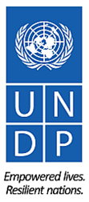
United Nations Development Programme
Interim Financial Report to the UNDP Funding Windows
As of 31 December 2017
Contributions reference no.  Country:  Project description:  Project:  Output description:  Output:  Output status:  Fund: |  | 00107382  Central African Republic  Programme Conjoint Jeunes RCA  00102665  Programme Conjoint Jeunes RCA  00104638  On Going  GIPS -Global
 |  |  | (in United States dollars)
 |  |  | Prior years | 2017 | Cumulative to 2017
 |  |  | (1) | (2) | (3)
Income/Revenue
Contributionsᵃ |  |  | - | 150 000,00 | 150 000,00
Other Revenueᵇ |  |  | - | - | -
Transfer to/from other funds |  |  | - | - | -
Refunds to donors |  |  | - | - | -
Total - Income/Revenue |  |  | - | 150 000,00 | 150 000,00
Expenses
Staff and other personnel costs |  |  | - | 8 722,89 | 8 722,89
Supplies, commodities, materials |  |  | - | 6 446,87 | 6 446,87
Equipment, vehicle and furniture including  depreciation |  |  |  | - | -
Contractual services |  |  | - | 49 385,24 | 49 385,24
Travel |  |  | - | - | -
Transfers and grants to counterparts |  |  | - | 23 568,00 | 23 568,00
General operating and other direct costs |  |  | - | 52 057,43 | 52 057,43
Subtotal |  |  | - | 140 180,43 | 140 180,43 | 0 | 0
Programme support costsᶜ |  |  | - | 9 819,57 | 9 819,57
Total Expenses |  |  | - | 150 000,00 | 150 000,00 | 0 | 0
Balanceᵈ |  |  | - | (0,00) |  |  | (0,00)
Future Expensesᵉ
Balance of un-depreciated assets & inventory  purchased |  |  |  | - | -
Commitments |  |  | - | - | -
Subtotal |  |  | - | - | -
Receivableᵉ
Less: Contributions receivable from donors |  |  | - | - | -
Available Resourcesᶠ |  |  | - | (0,00) | (0,00)
a. Contributions represent recognized revenue from donors based on the payment schedule in signed agreements.
b. Other Revenue represents revenue resulting from miscellaneous activities.
c. Programme support (indirect) cost is calculated based on the expenses excluding amounts of foreign exchange gain/loss.
d. Balance in column (2) is inclusive of balance in column (1).
e. Future expenses and Receivable - amounts in column (2) are the balances outstanding as of the report date which are included in the available resources. Amounts in column (1) are shown for information purpose only.
f. Available resources - balance after future expenses, and contributions receivable from donors (i.e. amounts past due) have been accounted for.
This is to certify that the above statement of revenue, expenses and available resources is correct and that the expenses were incurred in connection with the approved projects for which funds have been received.

____________________________________________________________________________________

(Signature) (Date)

Attachment 1 : Testimonies from the youth beneficiaries from PK5
The Funding Windows allowed for the creation of emergency jobs for the youth-at-risk in the PK5 district of Bangui, a predominantly Muslim district and scene of violence during the crisis.

Témoignage de Victor, délégué de la communauté
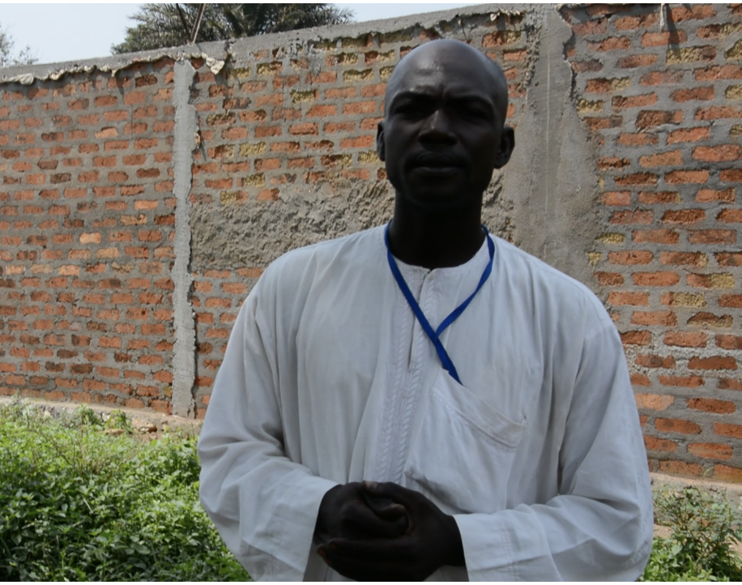
« Les activités de sensibilisation sont vraiment appréciées par la communauté entière particulièrement par les jeunes parce que cela leur apporte des connaissances. Il y a des jeunes qui ont arrêté leurs études à bas niveau et après les activités THIMO, ils peuvent suivre des formations dans des différents domaines et chacun aura un diplôme et peut être cela lui pourra servir d’emploi. Ceci construit énormément le future pour le pays. C’est l’avenir de la République Centrafricaine qui est engagé dans ces activités-là. »

Témoignage d’Ancene Ngoba, coordinateur du marché a PK5, 3è arrondissement.
« Après un incident vers le cinquième dans lequel une grenade a été lance pendant un concert le 11 novembre 2017, les activités commerciales qui ont été arrêté ont repris à nouveau avec l’appui des activités génératrices de revenu. Nous nous sommes mis à travailler pour sensibiliser les communautés d’une partie et de l’autre pourvue que le calme revient. Et effectivement le calme est revenu très rapidement grâce aux gens qui ont pris conscience pour éviter qu’il y ait de représailles sur le terrain. Nous faisons la sensibilisation de proximité auprès de la communauté. La population est victime de manipulations, de fausses rumeurs, ce ça qui fait qu’il y ait des réactions un peu partout. C’est des rumeurs non vérifiées qui font que le gens rentre dedans. Nous sommes présentement sur le terrain avec cette activité qui a engagé beaucoup de gens à travers le projet « Jeunes a risque » appuyé par le PNUD. Nous sommes en train de faire les activités THIMO (Travail à Haute Intensité de Main d’Œuvre) dans certains quartiers du 3è arrondissement depuis que la crise a déclenchée. Les jeunes sont toujours avec nous en train de faire le THIMO et on les sensibilise pour ne pas se laisser faire. Premièrement le THIMO montrent le sens du travail manuel aux jeunes pour qu’ils aient cette habitude de savoir travailler à la main. Après cette activité rémunérée, il y aura la formation socio-professionnelle et les jeunes pourront acquérir certaines connaissances dans les différents domaines (mécanique, hostellerie, maraîchage) selon la motivation de toute un chaque un des bénéficiaires. »

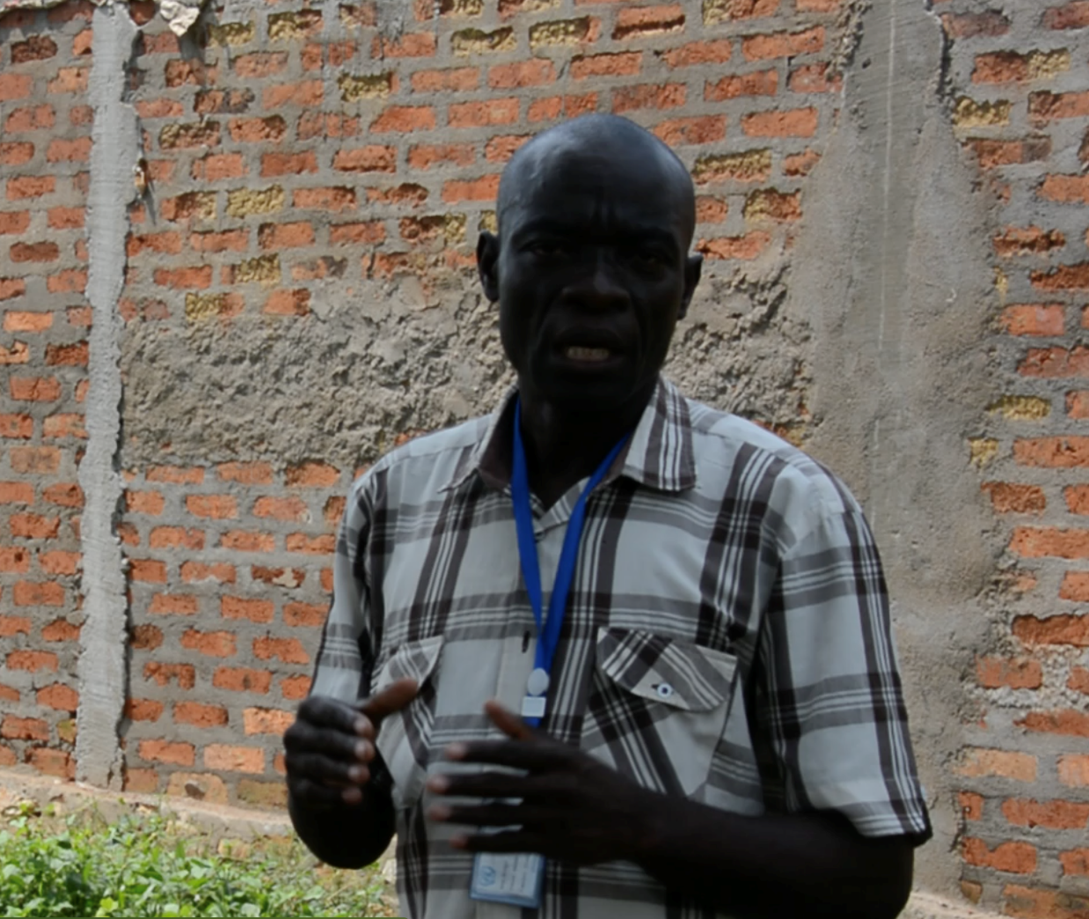
Attachment 2:
Testimony of one of the youth beneficiaries of the training on Entrepreneurship funded by UNDP/FW to provide alternative livelihood options for the disenfranchised youth affected by the conflict
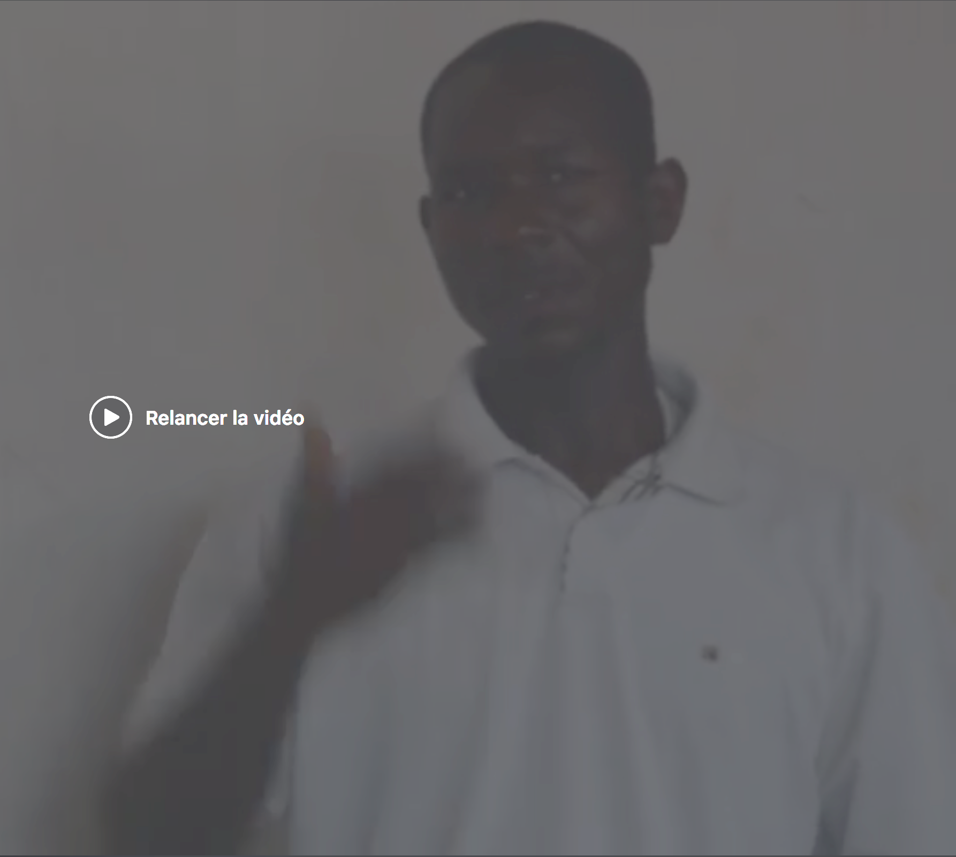
Mougbia Sando Jean Paul, du 8è à Bangui
« Cette formation peut m’aider à construire ma vie. J’étais commerçant mais je ne faisais pas confiance à la banque. Je faisais du commerce et dans ces évènements j’ai tout perdu. Maintenant pour réhabiliter mon commerce, c’était difficile. Quand j’étais venu à cette formation dès le premier jour que notre formateur a fait le briefing ça m’a touché. Il a dit quelque chose : « Si tu n’as pas une ambition qui t’effraie c’est que tu n’as pas encore une ambition ». Et cette phrase m’a beaucoup touché. Dès le début de cette formation j’ai pris une décision : « Qu’est-ce que je vais faire pour avoir une ambition et reconstruire ma vie ? ». Et c’était sur cette citation je me suis dit je vais maintenant acheter une pousse et 20 bidons vides pour vendre de l’eau potable. Vous savez que nous sommes en saison sèche. Et j’ai commencé à économiser mille francs - mille francs. Je l’ai fait depuis le premier décembre. Les deux fêtes qui viennent de passer, je n’ai pas pu fêter. J’ai économisé mille francs - mille francs et maintenant vous savez que l’huile de palme commence à augmenter. Ma femme vend l’huile de palme et m’a dit : « Est-ce que tu as de l’argent pourvue que nous puissions acheter de l’huile de palme ? » Je lui ai remis 34 mille. Elle est allée acheter 4 bidons et nous avons mis ça à la maison. Bientôt ça va devenir 12500 et je vais avoir 50000. Et c’était comme ça que j’ai fait mes économies. Je continue toujours dans ce sens. Le mois de janvier j’ai encore acheté 15 bidons et j’ai embauché quelqu’un d’autre. Cette formation m’a vraiment touché parce que j’ai eu une ambition qui va me permettre de reconstruire ma vie et aussi d’embaucher les autres et d’aider notre communauté à se développer. Et vous devez savoir que dans notre pays il y a beaucoup des gens qui font du commerce mais qui ne font pas confiance à la banque ; qui ne savent même pas comment gérer leurs affaires. C’est pour cela que cette formation ne devrait pas se limiter à notre niveau mais il faut l’élargir : comme ça les jeunes centrafricains vont bénéficier ».
Bangui, le 13 janvier 2018
Attachment 3:
Photos of the various interventions financed by UNDP/Funding Windows
- Photos of the social cohesion sensitization sessions
Weekly sensitization sessions on peace and social cohesion provided the beneficiaries with the occasion to reflect on the need for dialogue and peaceful coexistence with members of other religious communities.
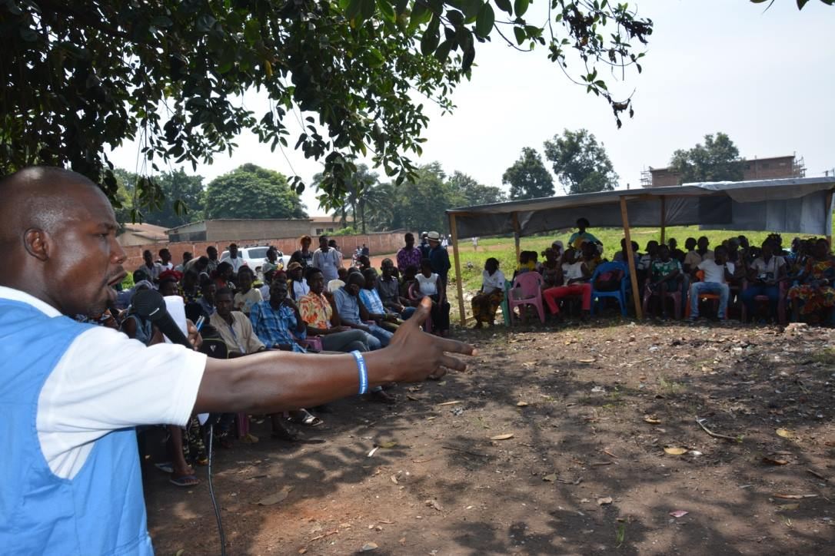

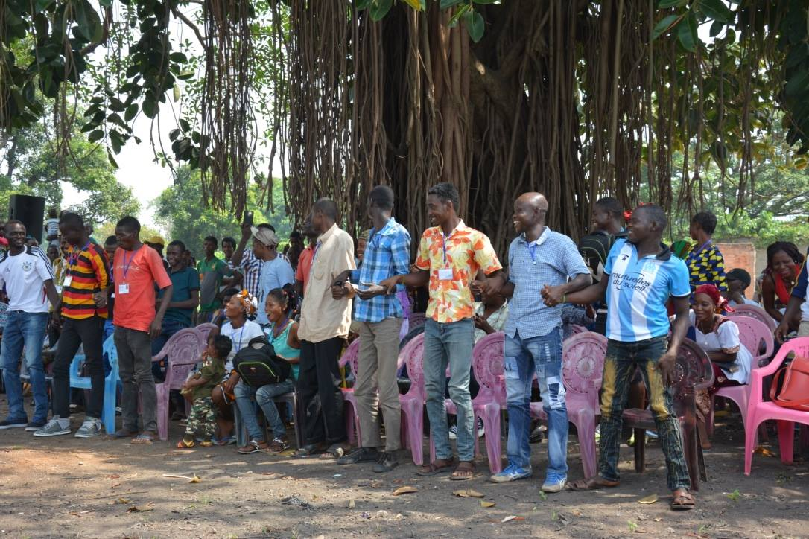

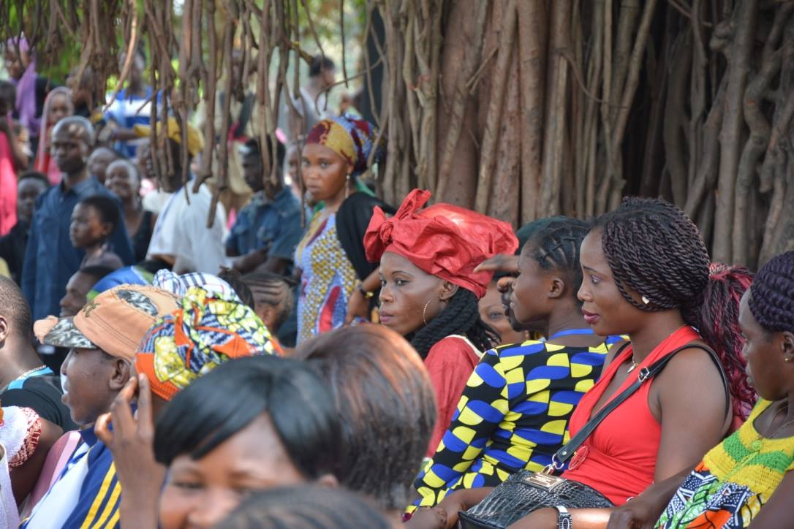

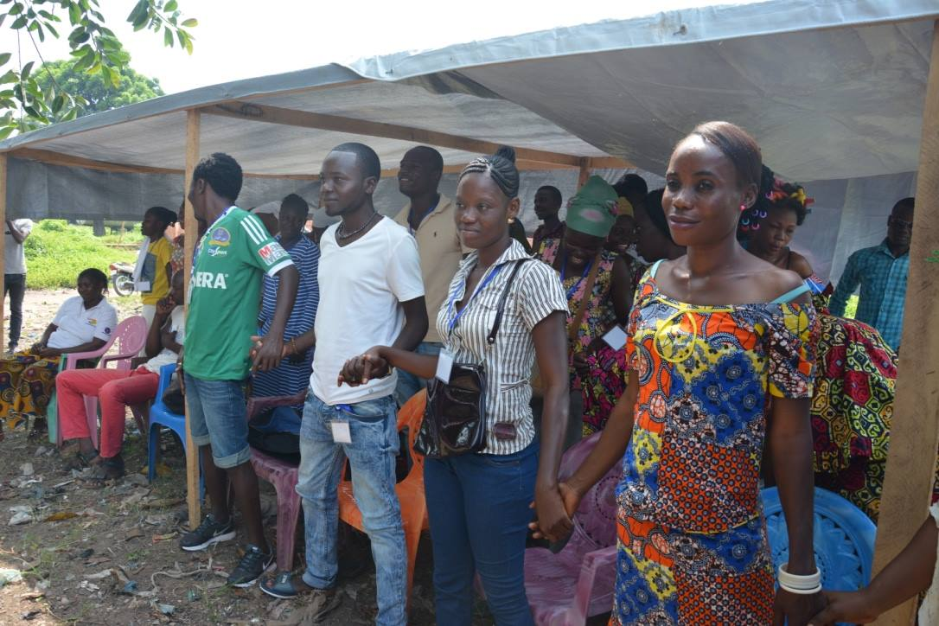

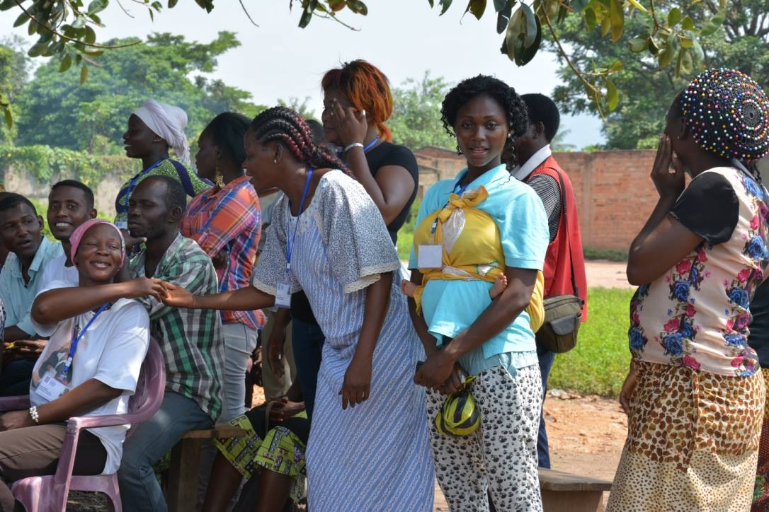

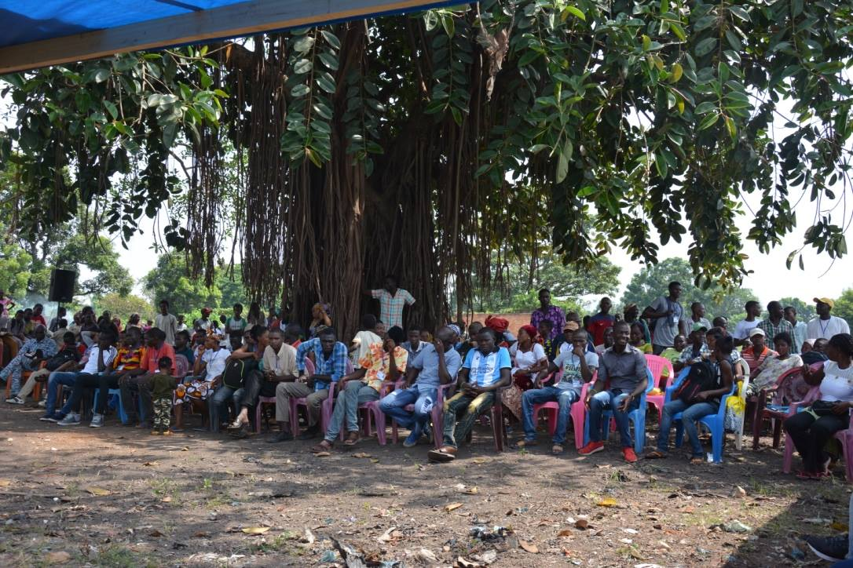

- Photos of the Emergency Employment activities
The work-for-peace activities allowed several streets to be cleared of bandits that took advantage of the weed cover to avoid early detection. At the same time, it provided income for the youth and allowed them to save some funds to pursue vocational training leading to income-generating activities
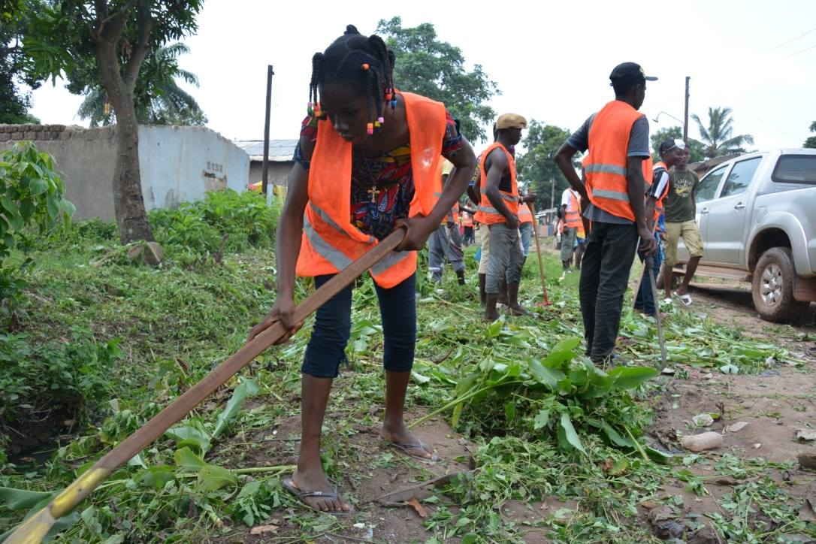

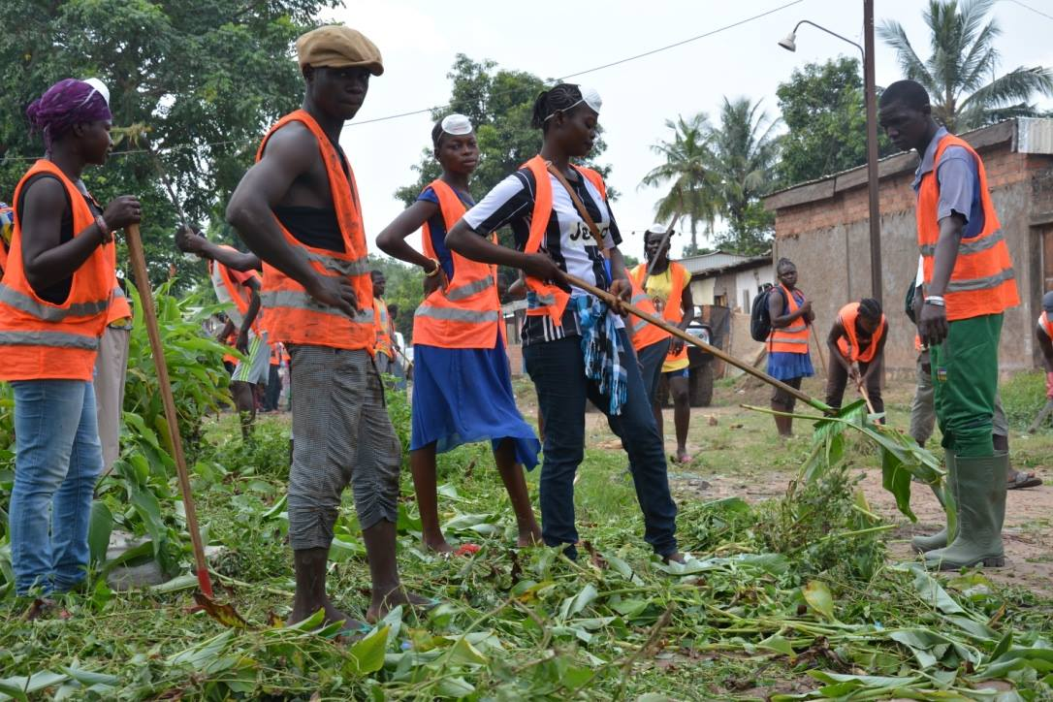

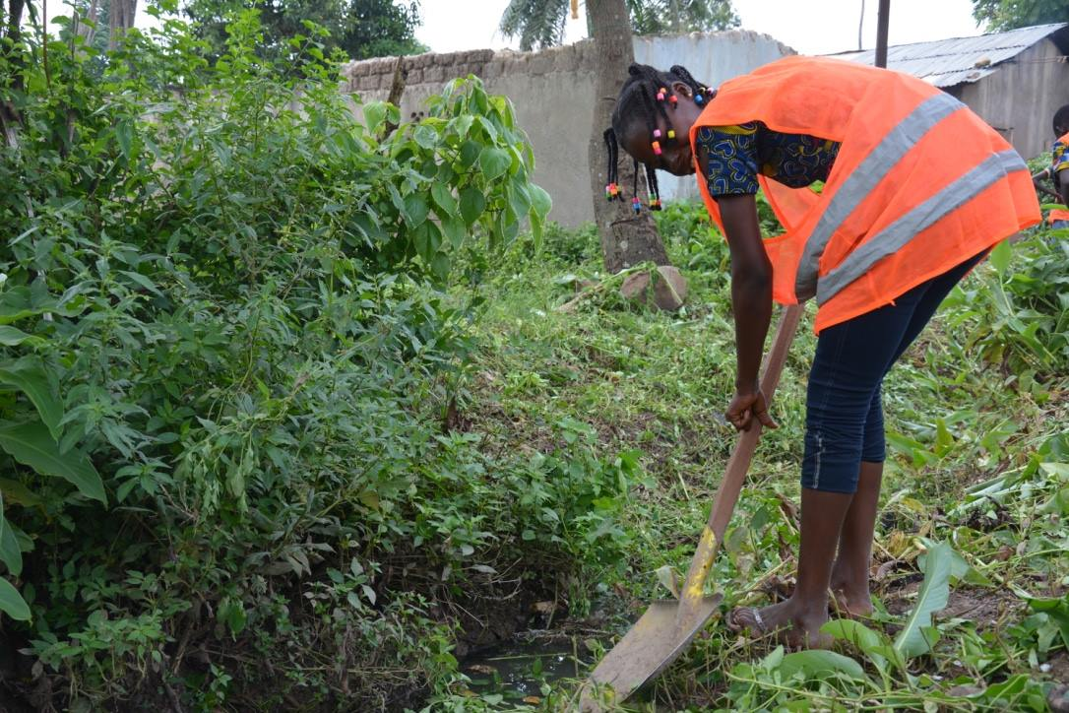

- Training on entrepreneurship and validation of the Code on SMEs
Interactive entrepreneurship training sessions provided a chance for the youth to learn practical knowledge on putting up their small businesses.

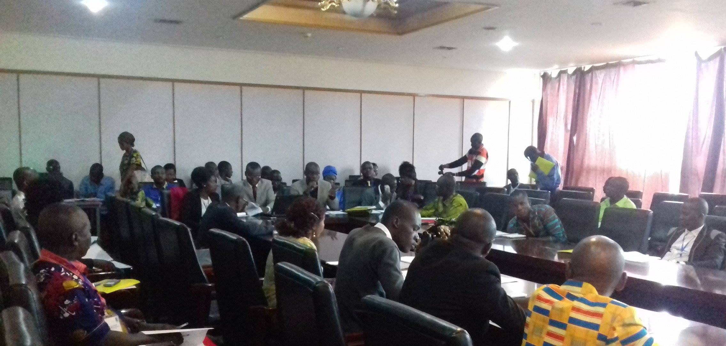
The validation session for the Code on SMEs/SMIs gave a boost for this code to be eventually promulgated and is expected to benefit youth and women in particular.

Attachment 4:
The first issue of the Newsletter of the Ministry on SMEs featured UNDP’s role in the various activities around the Code for SMEs/SMIs. This institutional policy framework will allow for the population to benefit from the various mechanisms planned to be put into reality.

